**PIZZA SALES SQL QUERIES**

**A.KPI’s**

**1.Total Revenue:**

select sum(total_price) as total_revenue from pizza_sales;

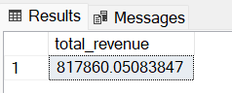

**2.Average Order Values:**

select sum(total_price)/count(distinct order_id) as Avg_Order_Value from pizza_sales;

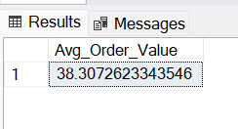

**3.Total Pizza Sold:**

select sum(quantity) as total_pizza_sold from pizza_sales;

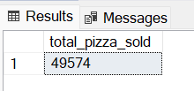

**4.Total Orders:**

select count(distinct order_id) as total_orders from pizza_sales;

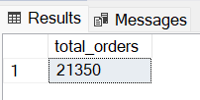

**5.Average Pizza per order:**

select CAST(CAST(SUM(quantity) as decimal(10,2))/CAST(COUNT(DISTINCT order_id) as decimal(10,2)) as decimal(10,2)) as average_pizzas_per_order from pizza_sales;

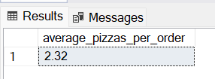

**6.Hourly Trend for total pizza sold**

select datepart(hour,order_time) as order_hour,sum(quantity) as total_pizza_sold from pizza_sales

group by datepart(hour,order_time)

order by datepart(hour,order_time);

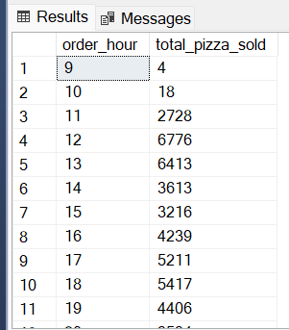

**7.Weekly Trend for total orders**

select datepart(iso_week,order_date) as week_number,year(order_date) as Order_year,count(Distinct order_id) as total_orders

from pizza_sales

group by datepart(iso_week,order_date),year(order_date)

order by datepart(iso_week,order_date),year(order_date);

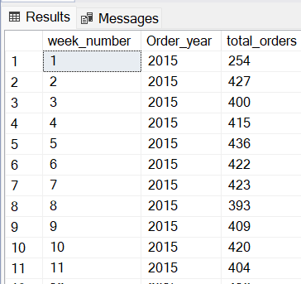

**8.** **percentage of pizza sold by pizza category**

select pizza_category,sum(total_price) *100/(select sum(total_price) from pizza_sales) as pct_total_sales

from pizza_sales

group by pizza_category

order by pizza_category;

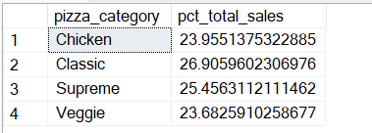

**9.** **percentage of pizza sold by pizza size**

select pizza_size,cast(sum(total_price) *100/ (select sum(total_price) from pizza_sales) as decimal(10,2)) as pct_total_sales

from pizza_sales

group by pizza_size

order by pizza_size;

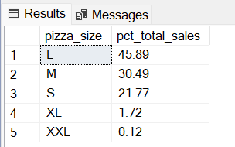

**10.Top 5 best-selling pizza names based on Revenue**

select top 5 pizza_name,sum(total_price) as total_revenue from pizza_sales

group by pizza_name

order by total_revenue desc;

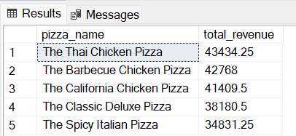

**11.Bottom 5 worst-selling pizza names based on Revenue**

select top 5 pizza_name,sum(total_price) as total_revenue from pizza_sales

group by pizza_name

order by total_revenue

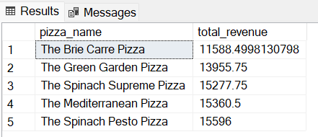

**12.Top 5 Best-selling pizza names based on Quantity**

select top 5 pizza_name,sum(quantity) as total_quantity from pizza_sales

group by pizza_name

order by total_quantity desc;

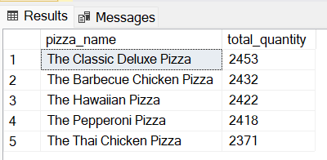

**13.Bottom 5 worst-selling pizza names based on Quantity**

select top 5 pizza_name,sum(quantity) as total_quantity from pizza_sales

group by pizza_name

order by total_quantity

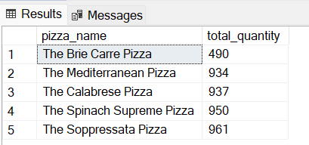

**14. Top 5 Best-selling pizza names based on Orders**

select top 5 pizza_name,count(distinct order_id) as total_orders from pizza_sales

group by pizza_name

order by total_orders desc

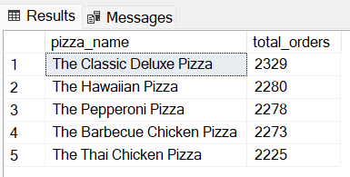

**15.Bottom 5 worst-selling pizza names based on Orders**

select top 5 pizza_name,count(distinct order_id) as total_orders from pizza_sales

group by pizza_name

order by total_orders

